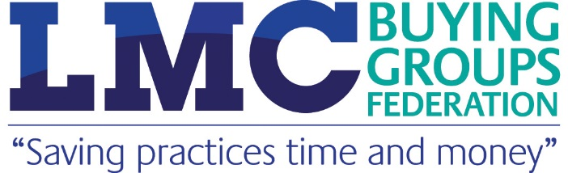

Who can save your practice £££?

In this period of financial uncertainty, we’d like to remind you about a really easy way for your practice to save thousands of pounds a year.

We hope that all GPs and practice staff in Gloucestershire are aware of the LMC Buying Groups Federation which is already saving local practices money.

The Federation now offers practices discounts on a wide range of products and services. A full list of our suppliers can be found here: www.lmcbuyinggroups.co.uk/suppliers.

‘Challenge Gary’

We’re so confident we can save you money that the Federation’s procurement consultant, Gary Burns, offers practices a free cost analysis to demonstrate the huge savings they could be making. All people have to do is send him an email detailing which areas you want him to analyse (e.g. office supplies, medical consumables, utilities etc) and he will work out how much you could save by switching suppliers.

Example: This mid-sized practice asked Gary Burns to analyse their spend in just four areas:

Product/Service | Buying Group Saving | Annual Saving | Buying Group Supplier
Office Stationery | 46% | £2,713 | Whittaker Office Solutions
Medical Consumables | 27% | £4,134 | MidMeds
Telecoms | 24% | £2,072 | Atech
Insurance | 24% | £2,331 | MIAB

TOTAL SAVINGS: £11,250

If you want to find out how much your practice could save email g.burns321@btinternet.com or visit our website at www.lmcbuyinggroups.co.uk. If Gary can’t save your practice money we will enter you into a free prize draw to win £50 of M&S vouchers.

